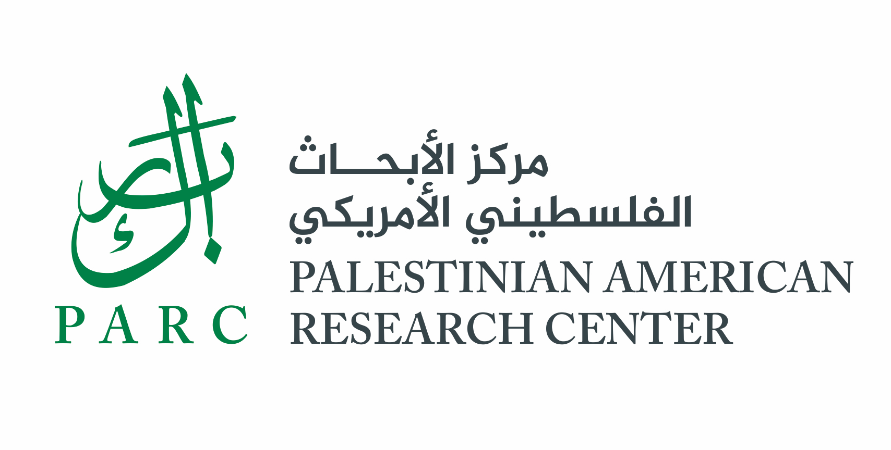
Please become a member, renew your membership, or make a donation to PARC

Name (s) ____________________________________________________________________
Address: ____________________________________________________________________
Email:________________________________ Telephone:__________________________

I would like to join or renew my membership at the following level:

□ Patron Member $500
□ Sponsoring Member $250
□ Supporting Member $100
□ Basic Member $45
□ Student Member $35

□ Institutional Patron Member $1,000
□ Institutional Sponsoring Member $500
□ Institutional Supporting Member $250
□ Institutional Basic Member $125
□ MSI & Community College Institutional Member $75

Payment Designation | Amount
Membership (please see levels above)
Area of greatest need
Palestinian Research Fellowships
Other: (please specify)
TOTAL AMOUNT

My gift will be matched by _____________________________________ company/foundation.
□ The matching gift form is enclosed. □ I will forward the matching gift form to PARC.

I would like to make my contribution in the form of: □ Check □ Stock (see below) □ Other

Please use the following name(s) for donor recognition:

______________________________________________________

Please make checks and corporate/foundation matches payable to the Palestinian American Research Center, and mail to: PARC, PO Box 19616, Washington, D.C. 20036-9616

For information about transferring a gift of stock, making a wire transfer, or creating a named Palestinian research fellowship, please contact us at usoffice@parc-us-pal.org.

The Palestinian American Research Center is a public 501(c)(3)
non-profit academic organization as described in IRS Publication 526.

